South Sudan

## Population Data

The data set shows the political stability estimate of the country each year.

## # A tibble: 23 x 5  
## country iso3c date population popCategory5  
## <chr> <chr> <dbl> <dbl> <chr>   
## 1 South Sudan SSD 1996 5221926 small   
## 2 South Sudan SSD 1997 5411655 small   
## 3 South Sudan SSD 1998 5661942 small   
## 4 South Sudan SSD 1999 5933882 small   
## 5 South Sudan SSD 2000 6199394 small   
## 6 South Sudan SSD 2001 6447793 small   
## 7 South Sudan SSD 2002 6688226 small   
## 8 South Sudan SSD 2003 6935676 small   
## 9 South Sudan SSD 2004 7213351 small   
## 10 South Sudan SSD 2005 7535932 small   
## 11 South Sudan SSD 2006 7907406 small   
## 12 South Sudan SSD 2007 8315139 small   
## 13 South Sudan SSD 2008 8736939 small   
## 14 South Sudan SSD 2009 9142259 small   
## 15 South Sudan SSD 2010 9508364 small   
## 16 South Sudan SSD 2011 9830698 small   
## 17 South Sudan SSD 2012 10113647 small   
## 18 South Sudan SSD 2013 10355036 small   
## 19 South Sudan SSD 2014 10554883 small   
## 20 South Sudan SSD 2015 10715658 small   
## 21 South Sudan SSD 2016 10832512 small   
## 22 South Sudan SSD 2017 10910759 small   
## 23 South Sudan SSD 2018 10975920 small

# Population growth data

## # A tibble: 23 x 5  
## country iso3c date popGrowth popGrowthCat5   
## <chr> <chr> <dbl> <dbl> <chr>   
## 1 South Sudan SSD 1996 2.01 moderate growth rate  
## 2 South Sudan SSD 1997 3.57 high growth rate   
## 3 South Sudan SSD 1998 4.52 high growth rate   
## 4 South Sudan SSD 1999 4.69 high growth rate   
## 5 South Sudan SSD 2000 4.38 high growth rate   
## 6 South Sudan SSD 2001 3.93 high growth rate   
## 7 South Sudan SSD 2002 3.66 high growth rate   
## 8 South Sudan SSD 2003 3.63 high growth rate   
## 9 South Sudan SSD 2004 3.93 high growth rate   
## 10 South Sudan SSD 2005 4.37 high growth rate   
## 11 South Sudan SSD 2006 4.81 high growth rate   
## 12 South Sudan SSD 2007 5.03 high growth rate   
## 13 South Sudan SSD 2008 4.95 high growth rate   
## 14 South Sudan SSD 2009 4.53 high growth rate   
## 15 South Sudan SSD 2010 3.93 high growth rate   
## 16 South Sudan SSD 2011 3.33 high growth rate   
## 17 South Sudan SSD 2012 2.84 high growth rate   
## 18 South Sudan SSD 2013 2.36 moderate growth rate  
## 19 South Sudan SSD 2014 1.91 moderate growth rate  
## 20 South Sudan SSD 2015 1.51 moderate growth rate  
## 21 South Sudan SSD 2016 1.08 slow growth rate   
## 22 South Sudan SSD 2017 0.720 slow growth rate   
## 23 South Sudan SSD 2018 0.595 slow growth rate

## Population trend

The plot shows the population trend of the country.

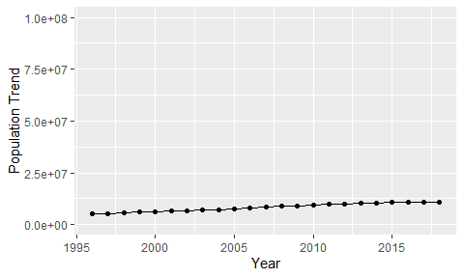

Political Stability Trend

# Population growth trend

The plot shows the population growth rate trend of the country.

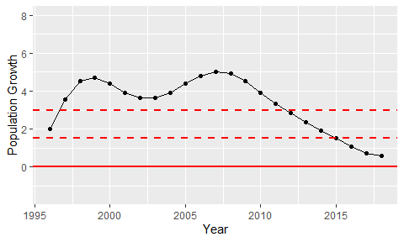

Population Growth Trend